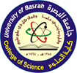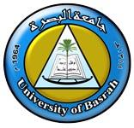
Ministry of Higher Education and Scientific Research
University of Basrah/ College of Science

وزارة التعليم العالي والبحث العلمي
جامعة البصره / كلية العلوم

السيرة الذاتية CURRICULUM VITAE
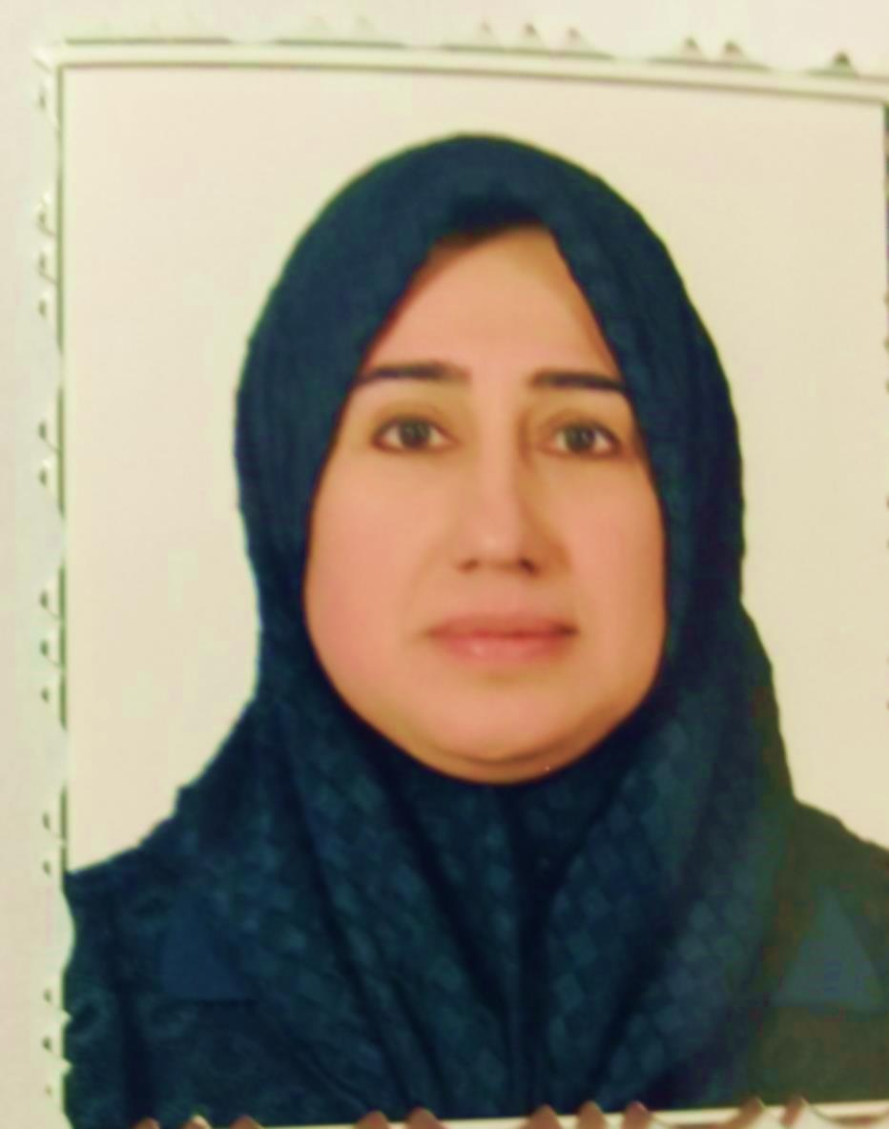

المعلومات العامة :

الاسم الثلاثي واللقب | هناء سلمان كاظم السوداني
Full Name
Hanaa S. Kadhim Al-Sudani
اللقــــــب العلــــمي | Title  استاذ مساعد  Assistant Professor
الجامعــــــــــــــــة | University  BASRAH  البصرة
الكليـــــــــــــــــــة | College  SCIENCE  العلوم
القســــــــــــــــــــم | Department  Biology  علوم الحياة
البريد الألكتروني الرسمي | Official E-mail  Hanaa.salman7338@yahoo.com

المؤهــــــــلات والسيرة العلمية |  |  |  | Qualification and certification
الاختصاص العام |  | علم الحيوان |  | Zoology |  | General specialization
الاختصاص الدقيق |  | الفسلجه |  | physiology |  | Specific specialization
الشهادة | تاريخها | الجامعة | البلد | Country | University | Date | Certificate
بكلوريوس | 1994 | البصرة | العراق | Iraq | Basrah | 1994 | B.Sc.
ماجستير | 1999 | البصرة | العراق | Iraq | Basrah | 1999 | M.Sc.
دكتوراه | 2015 | البصره | العراق | Iraq | Basrah | 2015 | Ph.D.
 |  |  |  |  |  |  | Others

الإشراف على الدراسات العليا |  |  | Postgraduate Supervision
اسم الطالب  Student Name | الجامعة/ الكلية / القسم  Univ./Coll./Dept. |  |  | الشهاده  Degree | السنه  Date
رافدة مجيد عبد الحسين | Basra/science/Biology |  |  | Master | 2017

نشاط التدريس |  |  |  | Teaching
دراسات اولية Undergraduate Studies
رمز المقرر | اسم المقرر |  |  | Course name |  |  | Course code.
ب321 | فسلجة حيوان |  |  | ANIMAL PHYSIOLOGY |  |  | B321
ب473 | علم الدم |  |  | HEMATOLOGY |  |  | B473
ب101 | علم الحيوان |  |  | ZOOLOGY |  |  | B101
ب102 | بايلوجي عام |  |  | GENERAL BIOLOGY |  |  | B102
ب 424 | تشريح مقارن |  |  | Comprative Anatomy |  |  | B424
ب 431 | فسلجة احياء مائيه |  |  | AQUATIC MICROORGANISM |  |  | B431
ب487 | انزيمات |  |  | Enzymology |  |  | B487
ت103 | تشريح بشري |  |  | Anatomy |  |  | PA103
دراسات عليا Postgraduate Studies
الموضوع |  |  |  | Course name
فسلجة متقدم |  |  |  | Advanced physiology
هرمونات |  |  |  | Endocrinology
امراض دم |  |  |  | Hematological Disorders
الكتب المؤلفة Book publication
اسم الكتاب |  | سنة النشر | البلد | country | Year | Book Title

البحوث المنشورةوبراءة الأختراع | Articles / Patents
Article & Patents details |  | No.
Adnan Issa AL badran , Ikbal Abdul Aziz AL rufaei and Hanaa Salman Al sudani  (2016) The histopathological effect of selenium - and vitamin E on liver  and testis ofDomestic Lepuslepus rabbits Vol. (34) .B(1)1-8, |  | 1-
Mahdi M. Thuwaini, Mohammed Abdul-Mounther and Hanaa S. Kadhem(2016) HEPATOPROTECTIVE EFFECTS OF THE AQUEOUS EXTRACT OF CLOVE (SYZYGIUMAROMATICUM) AGAINST PARACETAMOL-INDUCED HEPATOTOXICITY AND OXIDATIVE STRESS IN RATS.  EUROPEAN JOURNAL OF PHARMACEUTICAL AND MEDICAL RESEARCH www.ejpmr.com |  | 2-
Mahdi,M and Hanaa Salman Al sudani(2015) Hepatoprotective effects of simvastatin on paracetamol – induced hepatic damage in rats.IOSR J OF PHARM.5(6):2319-4219 |  | 3-
Shatha Q. Al-Timimi, Hanaa S. Kadhem, Mahdi M. Thuwaini (2016) The effect of physical exercises in the morning and evening time on some physiological parameters. Journal of Thi-Qar University Volume.11 No.3 Seb. |  | 4-
Hanaa Salman Al sudani(2006)Choosing of some blood parameters as an indicators for radiation exposure in experimental rabbits . Basrah,j.veternary research,vol.5,No.2. |  | 5-
Mohammed Abdul-Mounther Ali Abdul Aziz Al-shawiHanaa S. KhademMahdi M. Thuwaini (2017) Levels of serum prolactin and estradiol hormone of pre-and postmenopausal women breast cancer in misan city –Iraq: Comparative study. Scholars Journal of Applied Medical Sciences (SJAMS)  Sch. J. App. Med. Sci., 2017; 5(6B):2175-2178 |  | 6-
Mahdi M. Thuwaini, Hanaa S. Kadhem, Karim H. Al-Dierawi (2016) NEPHROPROTECTIVE ACTIVITY OF MATRICARIA CHAMOMILE AND CURCUMA LONGA AQUEOUS EXTRACTS ON TETRACYCLINEE-INDUCED NEPHRO-TOXICITY IN ALBINO RATS. International Journal of Pharmacy & Therapeutics, 7(4), 2016, 161-167 |  | 7-
Hanaa, S.Kadhum. ,Taha, J. Al-Taha , and Ali F. Al-Assady (2017) Relationship between serum adiponectin and apelin hormones with lipid profile in Basra pregnant women. Journal of Thi-Qar University Vol.12 No.1 Mar. |  | 8-
Mahdi, M.thuwaini, Karim, H. Al-Derawi, Hanaa, S.Kadhem (2018) The possible protective effect of Carthmus tinctorius (leaves) in antituberculosis (Rifampun& Isoniazid) drugs-induced hepatotoxicity in rats. Intrnational Journal of Pharmaceutical Research Vol.11No.1 |  | 9-
Rafida M. AL-Amiri ,Hanaa S.Khadum and Awatif H.Issa ( 2019 ) Changes In Gases, Electrolyte and Lactate acld during Normal Delivery and Caesarean section. Scientific journal of medical research Vol.3. |  | 10-
Rafeda M.AL-Amiri, Hanaa S.Kadhum , Awatif H.Issa (2019) Study the Effect of some Hormones on Type of Labor. Vol.10 No.4
مصادقة رئاسة الجامعة
مصادقة الكلية

